 | Course Name: Design Patterns/Thinking LAB | EXPERIMENT NO. 13
 | Course Code: 20CP210P  Faculty: Dr. Payal Chaudhari | Branch: CSE | Semester: IV
(To be filled by Student)
Submitted by: Meet Jain
Roll no: 23BCP093

Objective: To familiarize students with standard Behavioral design patterns.
Experiment: Explain the observer design pattern and write a program using any object-oriented programming language to demonstrate the working of observer design pattern.

Code:
import java.util.ArrayList;
import java.util.List;

interface Observer {
void update(String status);
}

interface Subject {
void addObserver(Observer o);
void removeObserver(Observer o);
void notifyObservers();
}

class Order implements Subject {
private String status;
private final List<Observer> customers = new ArrayList<>();

public void setStatus(String status) {
this.status = status;
notifyObservers();
}

public void addObserver(Observer o) {
customers.add(o);
}

public void removeObserver(Observer o) {
customers.remove(o);
}

public void notifyObservers() {
for (Observer o : customers) {
o.update(status);
}
}
}

class Customer implements Observer {
private final String name;

public Customer(String name) {
this.name = name;
}

public void update(String status) {
System.out.println("Hey " + name + ", your order is " + status + "!");
}
}

public class CafeObserver {
public static void main(String[] args) {
Order order = new Order();

Customer alice = new Customer("Alice");
Customer bob = new Customer("Bob");

order.addObserver(alice);
order.addObserver(bob);

System.out.println("Barista: Preparing the order...");
order.setStatus("Ready");
}
}

Output:
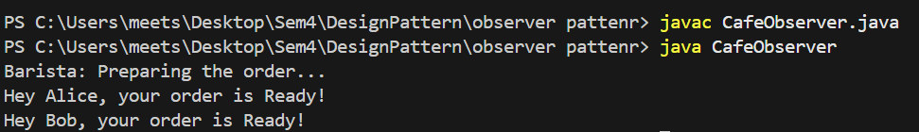
Class Diagram:
